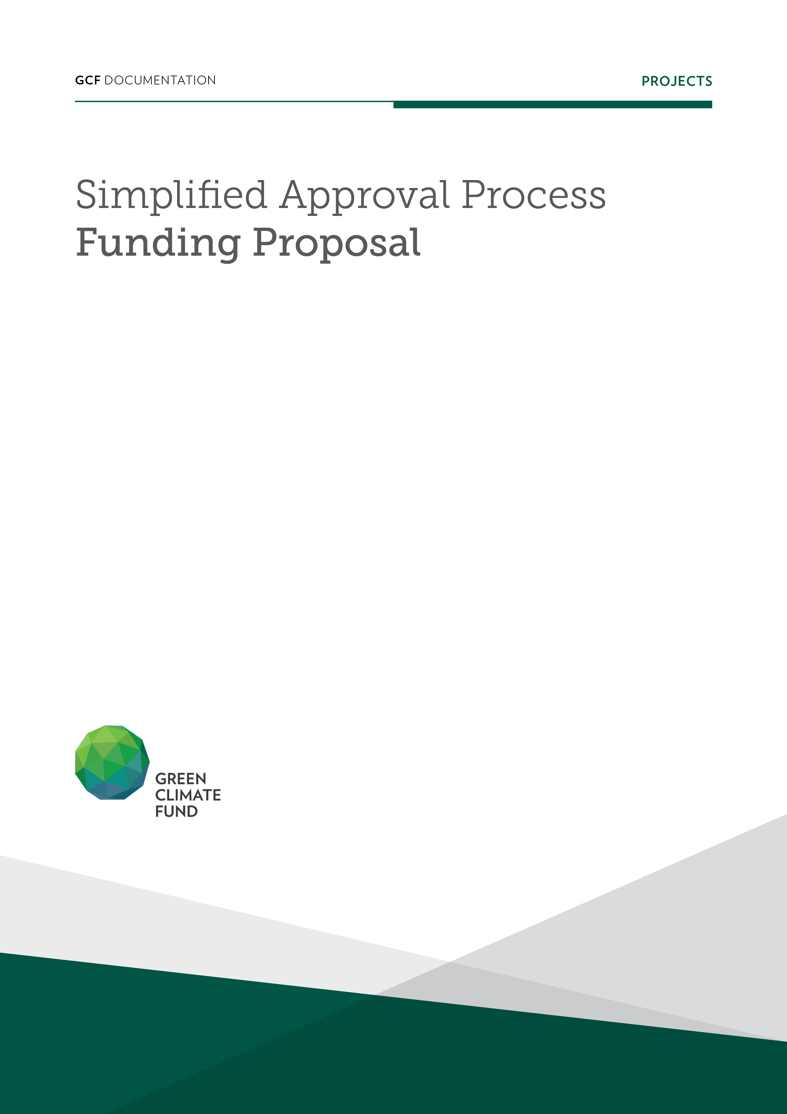

Project/Programme title: | Please indicate the project title; ideally this should reference the country where the project/programme will be implemented.
Country(ies): | List all the countries where the project/programme will be implemented.
National Designated Authority(ies): | Indicate the National Designated Authority(ies) of the country(ies) where the project/ programme will be implemented. This should match the NDAs on the submitted no objection letter(s).
Accredited Entity: | Indicate the accredited entity submitting this proposal.
Date of first submission: | [YYYY/MM/DD]
Date of current submission/ version number | [YYYY/MM/DD] [V.000]
If available, indicate GCF code: | This code is assigned to each project upon first submission of a Concept Note or Funding Proposal and remains the same throughout the proposal review process. If you have submitted this project/programme previously please indicate the GCF code here.

Contents

Section A PROJECT / PROGRAMME SUMMARY
This section highlights some of the project’s or programme’s information for ease of access and concise explanation of the funding proposal.

Section B PROJECT / PROGRAMME DETAILS
This section focuses on describing the context of the project/programme, providing details of the project/programme including components, outputs and activities, and implementation arrangements.

Section C FINANCING INFORMATION
This section explains the financial instrument(s) and amount of funding requested from the GCF as well as co-financing leveraged for the project/programme. It also includes justification for requesting GCF funding and exit strategy.

Section D LOGIC FRAMEWORK, AND MONITORING, REPORTING AND EVALUATION
This section includes the logic framework for the project/programme in accordance with the GCF Results Management Framework and Performance Measurement Framework, and gives an overview of the monitoring, reporting and evaluation arrangements for the proposed project/programme.

Section E EXPECTED PERFORMANCE AGAINST INVESTMENT CRITERIA
This section provides an overview of the expected alignment of the projects/programme with the GCF investment criteria: impact potential, paradigm shift, sustainable development, needs of recipients, country ownership, and efficiency and effectiveness.

Section F ANNEXES
This section provides a list of mandatory documents that should be submitted with the funding proposal as well as optional documents and references as deemed necessary to supplement the information provided in the funding proposal.

Note to accredited entities on the use of the SAP funding proposal template
- The Simplified Approval Process Pilot Scheme (SAP) supports projects and programmes with a GCF contribution of up to USD 10 million with minimal to no environmental and social risks. Projects and programmes are eligible for SAP if they are ready for scaling up and have the potential for transformation, promoting a paradigm shift to low-emission and climate-resilient development.
- This template is for the SAP funding proposals and is different from the funding proposal template under the standard project and programme cycle. Distinctive features of the SAP funding proposal template are:
- Simpler documents: key documents have been simplified, and presented in a single, up-front list;
- Fewer pages: A shorter form with significantly fewer pages. The total length of funding proposals should not exceed 20 pages;
- Easier form-filling: fewer questions and clearer guidance allows more concise and succinct responses for each sub-section, avoiding duplication of information.
- Accredited entities can either directly incorporate information into this proposal, or provide summary information in the proposal with cross-reference to other funding proposal documents such as project appraisal document, pre-feasibility studies, term sheet, legal due diligence report, etc.
- Submitted SAP Pilot Scheme funding proposals will be disclosed simultaneously with submission to the Board, subject to the redaction of any information which may not be disclosed pursuant to the GCF Information Disclosure Policy.

Please submit the completed form to:
fundingproposal@gcfund.org
Please use the following name convention for the file name:
“SAP-FP-[Accredited Entity Short Name]-[yymmdd]”

- PROJECT/PROGRAMME SUMMARY
A.1. Has this FP been submitted as a SAP CN before? |  |  | Yes ☐ No ☐
A.2. Is the Environmental and Social Safeguards Category C or I-3? |  |  | Yes ☐ No ☐
A.3. Project or programme | Indicate whether this FP refers to a combination of several projects (programme) or one project.  ☐ Project  ☐ Programme | A.4. Public or private sector | ☐ Public sector  ☐ Private sector
A.5. Result area(s) | Indicate the result areas for the project/programme.  Mitigation: Reduced emissions from:  ☐ Energy access and power generation  ☐ Low emission transport  ☐ Buildings, cities and industries and appliances  ☐ Forestry and land use  Adaptation: Increased resilience of:  ☐ Most vulnerable people and communities, including women and girls  ☐ Health and well-being, and food and water security  ☐ Infrastructure and built environment  ☐ Ecosystem and ecosystem services
A.6. Total investment (GCF + co-finance) | _____ (million USD) | A.7. Total GCF funding requested | _____ (million USD)
A.8. Type of financial instrument requested for the GCF funding | Mark all that apply.  ☐ Grant ☐ Loan ☐ Equity ☐ Guarantees ☐ Others:
A.9. Division of GCF funding by thematic funding window (if applicable) | ______USD or ______ % Mitigation  ______USD or ______ % Adaptation  In case of cross-cutting project/programme, indicate the allocation of funding according to mitigation or adaptation activities. The sum of mitigation and adaptation should add to the amount indicated in field A.7.
A.10. Implementation period | Indicate the number of years the project/programme is expected to be implemented.  (i.e. From the effective date of the Funded Activity Agreement to the Completion Date)
A.11. Total project/ programme lifespan | Indicate the number of years over which the investment is effective. | A.12. Expected date of internal approval |  | Click or tap to enter a date.
A.13. Executing Entity information | If the Executing Entity(ies) is different from the Accredited Entity, indicate the full legal name of the Executing Entity and provide its country of registration and ownership as well as the type of organization (e.g. foundation).
A.14. Scalability and potential for transformation (Eligibility for SAP, max. 50 words)
Provide a brief description of how the proposed project/programme will scale-up the previous initiatives, and how it will promote paradigm shift to low-emission and climate-resilient development.
A.15. Project/Programme rationale, objectives and approach (max. 250 words)
Provide a brief description of project/programme including:
- Climate rationale of the project/programme
- Purpose and activities of the project/programme
- Climate impacts of the project/programme
- Rationale for use of GCF funding
- Short justification for chosen instrument to be financed by the GCF

- PROJECT/PROGRAMME DETAILS
B.1. Context and baseline (max. 500 words)
Describe the climate vulnerabilities and impacts, GHG emissions profile, and mitigation and adaptation needs that the prospective intervention is envisaged to address.
Describe the baseline senarios that the proposed intervention seeks to overcome (i.e. emissions baseline, climate vulnerability baseline, resilience/adaptation challenges).
Describe any recent or ongoing projects that are related to this FP, such as financing from Global Environmental Facility, Adaptation Fund, Climate Investment Funds or others, and how this project/programme complements these.
Describe the main root causes and barriers (social, gender, fiscal, regulatory, technological, financial, ecological, institutional, etc.) that need to be addressed.
B.2. Project/programme description (max. 1,000 words)
Describe the proposed set of components, outputs and activities that will address the identified barriers and lead to the expected project/programme objective. The description should be provided for each component, output and activity, and should include a clear rationale for the cause-effect relationship of the interventions in each component. Include description of the target beneficiaries.
This should summarize the project/programme-level log frame requested in annex 2 to the funding proposal.
B.3. Implementation / institutional arrangements (max. 750 words)
Provide a description of the project/programme implementation structure, outlining legal, contractual and institutional arrangements and the structure between the GCF, the Accredited Entity (AE) and/or the Executing Entity (EE) or any third parties (if applicable) and beneficiaries. Provide diagram that maps such arrangements and governance structure.

Provide information and an organogram on the financial flows between the AE and the EE(s) or any third party (if applicable), and the financial flows between the EE or any third party (if applicable) and beneficiaries. Also describe the financial flows in the context of applicable AE’s accreditation parameters (e.g. specialized fiduciary function).

[Sample organograms]
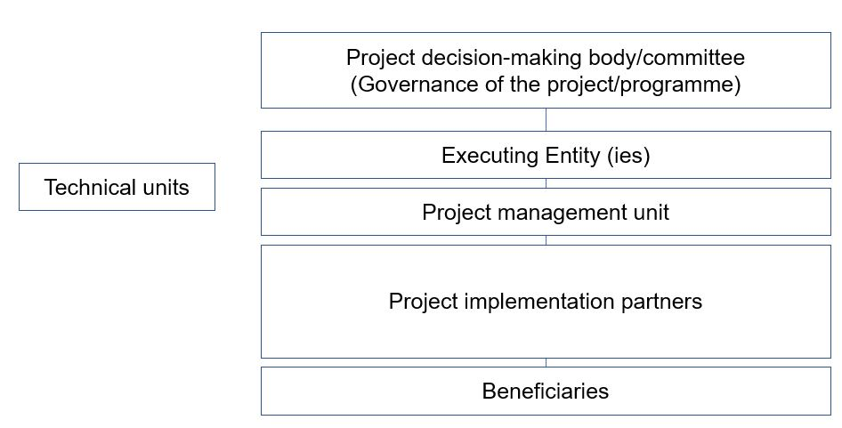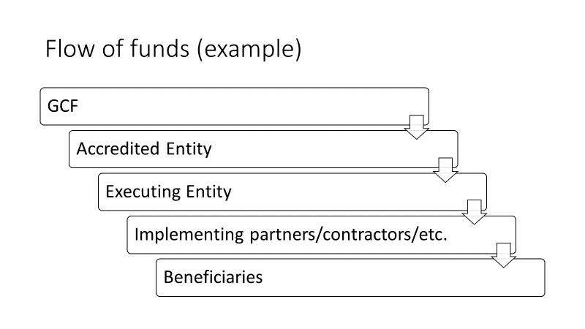

C. FINANCING INFORMATION
C.1. Total financing
(a) Requested GCF funding  (i + ii + iii + iv + v + vi) |  | Enter amount |  |  |  | Currency
GCF Financial Instrument |  | Amount |  | Currency |  | Tenor |  | Pricing
(i) | Senior loans | Enter amount |  | Options |  | Enter years |  | Enter %
(ii) | Subordinated loans | Enter amount |  | Options |  | Enter years |  | Enter %
(iii) | Equity | Enter amount |  | Options |  |  |  | Enter % equity return
(iv) | Guarantees | Enter amount |  | Options |  | Enter years |  | Enter %
(v) | Reimbursable grants | Enter amount |  | Options
(vi) | Grants | Enter amount |  | Options
(b) Co-financing information |  | Total amount |  |  |  | Currency
 |  | Enter amount |  |  |  | Options
Name of institution |  | Financial instrument | Amount |  | Currency | Tenor | Pricing |  | Seniority
Click here to enter text. |  | Options | Enter amount |  | Options | Enter years | Enter% |  | Options
Click here to enter text. |  | Options | Enter amount |  | Options | Enter years | Enter% |  | Options
Click here to enter text. |  | Options | Enter amount |  | Options | Enter years | Enter% |  | Options
Click here to enter text. |  | Options | Enter amount |  | Options | Enter years | Enter% |  | Options
- Total investment  (c) = (a)+(b) |  | Amount |  |  |  | Currency
 |  | Enter amount |  |  |  | Options
(d) Co-financing ratio  (d) = (b)/(a) |  | Total co-financing / total GCF funding amount
(e) Other financing arrangements for the project/programme (max ½ page) |  | Please explain if any of the financing parties including the AE would benefit from any type of guarantee e.g. sovereign guarantee, MIGA guarantee, etc.
C.2. Financing by component
Please provide an estimate of the cost per component (as outlined in Section B.2. above) and disaggregate by sources of financing.
Component | Output | Indicative cost  (USD) | GCF financing |  | Co-financing
 |  |  | Amount  (USD) | Financial Instrument | Amount  (USD) | Financial Instrument | Name of Institutions
Click here to enter text. | Click here to enter text. | Enter amount | Enter amount | Choose an item. | Enter amount | Choose an item. | Click here to enter text.
Click here to enter text. | Click here to enter text. | Enter amount | Enter amount | Choose an item. | Enter amount | Choose an item. | Click here to enter text.
Click here to enter text. | Click here to enter text. | Enter amount | Enter amount | Choose an item. | Enter amount | Choose an item. | Click here to enter text.
Click here to enter text. | Click here to enter text. | Enter amount | Enter amount | Choose an item. | Enter amount | Choose an item. | Click here to enter text.
Indicative total cost (USD) |  | Enter amount | Enter amount |  | Enter amount
This table should match the one presented in the term sheet and the names (in the rows) should match those presented in the logic framework in section D below.

Provide detailed information on the costs of the activities in annex 3 (budget).

If the project/programme is envisaged to support capacity building and technology development/transfer, please specify the total requested GCF amount for these activities respectively in this section.

For private sector proposals, provide an overview (diagram) of the proposed financing structure. Please note that this section should focus on describing what is being paid for, either by GCF funding and/or co-financing.

C.3. Justification for GCF funding request (max. 500 words)
Provide information why GCF is the appropriate donor for the proposed project/programme.
If applicable, inform if other donors at national and/or international level (including private sector) have been previously consulted to support this project/programme.
Describe the challenges to access finance (public and private). Also, describe the financial gaps and barriers that the proposed project/programme is expected to fill and address in the absence of any other financing.
In your answer, please consider the risk sharing structure between the public and private sectors, the barriers to investment and the indebtedness of the recipient (if applicable).
C.4. Exit strategy and sustainability (max. 250 words)
Elaborate how the project will be sustained after GCF exits the project. Specify the elements that will guarantee the sustainability of the investment, including essential information on the operation and maintenance of the activities in the post-implementation phase (e.g. key infrastructure, assets, contractual arrangements).

Please describe the GCF’s financial exit strategy in case of private sector (through IPOs, trade sales, etc.).

C.5. Financial management/procurement (max. 300 words)
Describe the project/programmer’s financial management including financial accounting standards, disbursement and procurement arrangements (details in Annex 8 for procurement). Explain how the AE will ensure that its fiduciary standards (based on its accreditation type) are adhered to at all times. Explain the methodology and frequency of the periodic financial reviews, reporting of the project expenditures including the audit requirements and the frequency of the audit to ensure that funds are used for the intended purposes and project complies with the covenants, if any.

D. LOGIC FRAMEWORK AND MONITORING, REPORTING AND EVALUATION
This section refers to the project/programme’s logic framework in accordance with the GCF’s Performance Measurement Framework under the Results Management Framework to which the project/programme contributes as a whole, including in respect of any co-financing. This is different from the project/programme-level log frame(as there may be other impact measures for example that go beyond those defined by the GCF).
A project-level logical framework, with specific indicators, baselines and targets, means of verification and assumptions should be provided as part of Annex 2.
D.1. Paradigm shift objectives
Choose appropriate expected result | Elaborate on the paradigm shift objectives to which the project/programme contributes.
Choose appropriate expected result | Elaborate on the paradigm shift objectives to which the project/programme contributes.
D.2. Impacts measured by GCF indicators
Select the appropriate impact for the project/programme. Note that more than one indicator may be selected per expected impact result. Add results as appropriate.
Expected Result |  | Indicator |  | Means of Verification (MoV) |  | Baseline |  |  | Target |  |  |  | Assumptions
 |  |  |  |  |  |  |  |  | Mid-term  (if applicable) |  | Final
Choose appropriate expected results |  | Please select relevant GCF indicators from the Fund’s performance measurement framework.  More than one indicator may be selected per expected impact result.
Choose appropriate expected results |  | Please select relevant GCF indicators from the Fund’s performance measurement framework.  More than one indicator may be selected per expected impact result.
Choose appropriate expected results |  | Please select relevant GCF indicators from the Fund’s performance measurement framework.  More than one indicator may be selected per expected impact result.
D.3. Outcomes measured by GCF indicators
Expected Outcomes | Indicator |  | Means of Verification (MoV) |  | Baseline |  | Target |  |  |  |  | Assumptions
 |  |  |  |  |  |  | Mid-term  (if applicable) |  |  | Final
Choose expected outcome | Please select relevant GCF indicators from the Fund’s performance measurement framework.
Choose expected outcome | Please select relevant GCF indicators from the Fund’s performance measurement framework.
Choose expected outcome | Please select relevant GCF indicators from the Fund’s performance measurement framework.
D.4. Arrangements for Monitoring, Reporting and Evaluation (max. 300 words)
Besides the arrangements (e.g. annual performance reports) laid out in the Accreditation Master Agreement, please provide project/programme specific institutional setting and implementation arrangements for monitoring, reporting and evaluation. Please indicate how the independent interim/mid-term and final evaluations will be organized, including the timing.

E. EXPECTED PERFORMANCE AGAINST INVESTMENT CRITERIA
E.1. Impact potential (max. 300 words)
E.1.1. Expected tons of carbon dioxide equivalent (t CO₂ eq) to be reduced or avoided (Mitigation only) |  | Annual | Click here to enter text. tCO₂ eq
 |  | Lifetime | Click here to enter text. tCO₂ eq
E.1.2. Expected total number of direct and indirect beneficiaries, disaggregated by gender |  | Direct | Click here to enter text.  Click here to enter text.% of female
 |  | Indirect | Click here to enter text.  Click here to enter text.% of female
 |  | *For both, Specify the % of female against the total number.
E.1.3. Number of beneficiaries relative to total population |  | Direct | Click here to enter text. (Expressed as %)
 |  | Indirect | Click here to enter text. (Expressed as %)
Describe the potential of the project/programme to contribute to the achievement of the Fund’s objectives and result areas. Specify the impact for mitigation and/or adaptation, as applicable.

E.2. Paradigm shift potential (max. 300 words)
Describe the degree to which the proposed activity can catalyze impact beyond a one-off project or programme
Investment.

In terms of rationale, please briefly describe the theory of change and provide information on how it serves to shift the development pathway toward a more low-emissions and/or climate resilient direction, in line with the Fund’s goals and objectives. This should summarize the diagram of the theory of change requested as an annex to the funding proposal.

Provide a summary of the potential for scaling up and replication, knowledge sharing and learning, and contribution to the creation of an enabling environment.

Describe overall contribution to climate-resilient development pathways consistent with relevant national climate change adaptation strategies and plans.
E.3. Sustainable development (max. 300 words)
Describe the wider benefits and priorities of the project/programmes in relation to the sustainable development goals and provide an estimation of the impact potential in terms of:
- Environmental co-benefits
- Social co-benefits
- Economic co-benefits
- Gender-sensitive development impact

Provide a summary of the gender assessment and project/programme-level gender action plan that is aligned with the objectives of GCF’s Gender Policy. Please provide the full gender assessment and project-level gender action plan as an annex to the funding proposal.

E.4. Needs of recipient (max. 300 words)
Describe the scale and intensity of vulnerability of the country and beneficiary groups, and elaborate how the project/programme addresses the issue (e.g. the level of exposure to climate risks for beneficiary country and groups, overall income level, etc).

Describe how the project/programme addresses the following needs:
  - Economic and social development level of the country and the affected population
  - Absence of alternative sources of financing (e.g. fiscal or balance of payment gap that prevents from addressing the needs of the country; and lack of depth and history in the local capital market)
  - Need for strengthening institutions and implementation capacity.
E.5. Country ownership (max. 500 words)
Please describe how the project/programme contributes to the country’s (or countries’) identified national priorities (e.g. country’s NDC, national climate strategies, relevant sectoral policies, or other plans such as Nationally Appropriate Mitigation Actions (NAMAs), National Adaptation Plans (NAPs), National Adaptation Programmes of Action (NAPAs), Technology Needs Assessments (TNAs), National Communications to the UNFCCC or equivalent). Please describe which priorities identified in these documents the proposed project is aiming to address and/or improve.

Please provide a full description of the steps taken to ensure country ownership, including engagement with relevant NDAs on the funding proposal design and applicable no-objection letter(s), and how the country ownership is embedded in scope and concept of the project/programme.

Please describe experience and track record of the AE and EE(s) with respect to the activities that they are expected to undertake in the proposed project/programme. Please mention the AE’s and EE’s experience in the country/region, in the sector and experience of handling projects of similar funding cost. Describe in what way the AE is well placed to undertake the planned activities and what will be the implementation arrangements with the EE(s) and implementing partners.

Describe the selection process and related consultations undertaken to ensure the proposed project/programme reflects a broad spectrum of stakeholder views, including the approval process by NDA for providing the no objection letter and criteria used for selection of the proposed activities, with a particular emphasis on gender and ESS consultations. Details on the stakeholders consultation carried out during the project proposal preparation can be reported as part of annex 2.

Briefly summarize the multi-stakeholder engagement plan and the consultations that were conducted when this proposal was developed.

E.6. Efficiency and effectiveness (max. 1 page)
E.6.1. Estimated cost per t CO₂ eq, defined as total investment cost / expected lifetime emission reductions (Mitigation only) | (a) Total project financing US$_______  (b) Requested GCF amount US$_______  (c) Expected lifetime emission reductions _______ tCO₂eq  (d) Estimated cost per tCO₂eq (d = a / c) US$_______ / tCO₂eq  (e) Estimated GCF cost per tCO₂eq removed (e = b / c) US$_______ / tCO₂eq
E.6.2. Expected volume of finance to be leveraged by the proposed project/programme and as a result of the Fund’s financing, disaggregated by public and private sources (Mitigation only) | (f) Total finance leveraged US$_______  (g) Public source finance leveraged US$_______  (h) Private source finance leveraged US$_______  (i) Total Leverage ratio (i = f / b) _______  (j) Public source leverage ratio (j = g / b) _______  (k) Private source leverage ratio (k = h / b) _______
Describe how the financial structure is adequate and reasonable in order to achieve the proposal’s objective(s), including addressing existing bottlenecks and/or barriers; providing the minimum concessionality; and without crowding out private and other public investment.

Provide the rationale of requested concessionality and explain the methodology and assumptions used to define it. Justify why the level of concessionality of the GCF financial instrument(s) is the minimum required to make the investment viable considering the incremental cost or risk premium of the project/programme. Additionally, how does the grant and the proposed pricing fit with the concept of minimum concessionality? Who benefits from concessionality? Refer to the financial analysis where appropriate.

Please describe the efficiency and effectiveness of the proposed project/programme, taking into account the total financing and mitigation/ adaptation impact the project/programme aims to achieve, and explain how this compares to an appropriate benchmark.

If an economic analysis applies to this SAP funding proposal, please specify the expected economic rate of return and net present value based on a comparison of the scenarios with and without the project/programme.

Provide summary of financial analysis provided as an annex and include (if applicable):
- Expected financial rate of return with and without the Fund’s support
- Identification of the financial needs and gaps
- Identification of the constraints and barriers to access finance
- Investment analysis with sensitivity under various stress scenarios wherever applicable
Please explain how best available technologies and practices have been considered and applied. If applicable, specify the innovations/modifications/adjustments that are made based on industry best practices.

F. ANNEXES
F.1. Mandatory annexes
☐ |  | Annex 1 |  | NDA No-objection Letter(s)
☐ |  | Annex 2 |  | Pre-feasibility study (including Theory of Change, project/programme-level log frame, timetable, map, and summary of stakeholder consultation and engagement plan)
☐ |  | Annex 3 |  | Budget plan that provides breakdown by type of expense (Template in excel sheet)
☐ |  | Annex 4 |  | Gender assessment and action plan (Template)
☐ |  | Annex 5 |  | Co-financing commitment letter
☐ |  | Annex 6 |  | Term sheet and evidence of internal approval
☐ |  | Annex 7 |  | Risk assessment and management (Template)
☐ |  | Annex 8 |  | Procurement plan (Template)
F.2. Other annexes to be submitted when applicable/requested
☐ | Annex 9 |  | Economic and/or financial analysis  (mandatory for private-sector proposals)
☐ | Annex 10 |  | Legal due diligence (regulation, taxation and insurance)
☐ | Annex 11 |  | Appraisal, due diligence or evaluation report for proposals based on up-scaling or replicating a pilot project
☐ | Annex 12 |  | Environmental and Social Action Plan (ESAP) and Environmental and Social Safeguards risk screening if changed from Part A and B of the concept note submitted.
☐ | Annex xx |  | Other references
* Please note that a funding proposal will be considered complete only upon receipt of all the applicable supporting documents.

Senior loans and subordinated loans.

