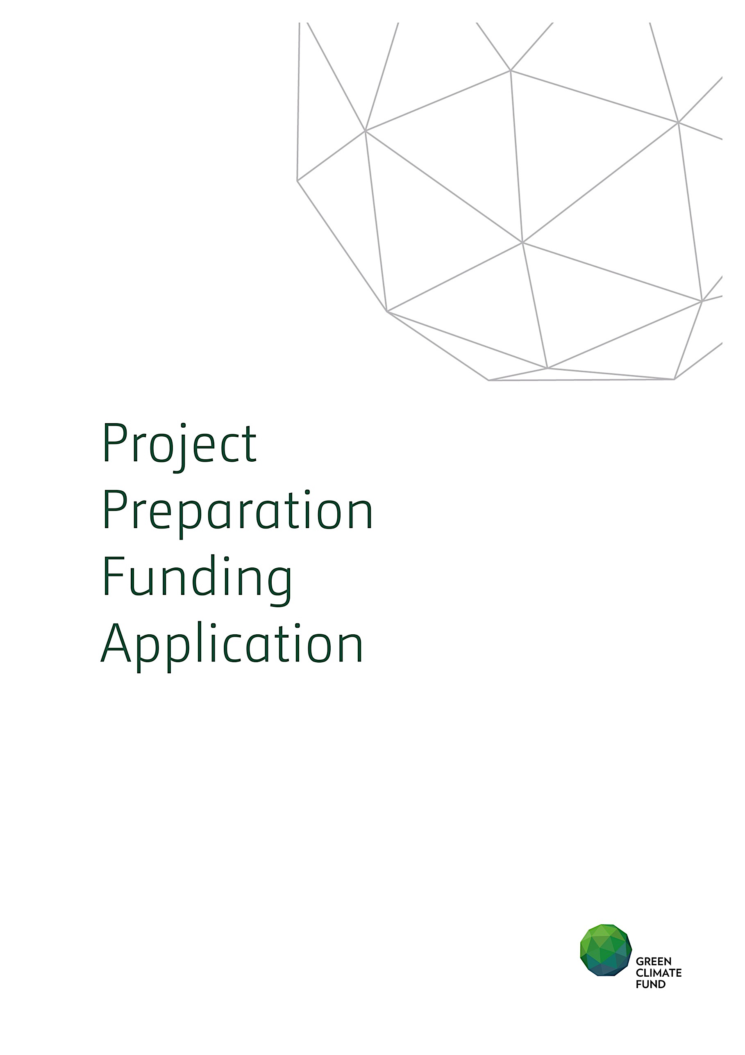

Request for Support from
the Project Preparation Facility (PPF)
Application Title
Country(ies)
Accredited Entity
Date of first submission/
Version number
Date of current submission/ version number | [YYYY-MM-DD] [V.0]
2017
Please submit the completed form to ppf@gcfund.org, using the following naming convention in the subject line and the file name:
“PPF-[Accredited Entity]- [Country]-yyyymmdd”
Notes
- The PPF supports the development of projects and programmes and enhance their quality at entry into the Fund’s pipeline. With a view to enhancing the balance and diversity of the project pipeline, the PPF is designed to especially support Direct Access Entities for projects in the micro-to-small size category. International Accredited Entities seeking project preparation support from the PPF are encouraged to do so especially for LDCs, SIDS and African countries where no Direct Access Entity is accredited. All Accredited Entities are encouraged to articulate counterpart support for project preparation within their requests for support from the PPF.
- A PPF submission should include below documents:
- PPF request (this form)
- PPF No-Objection letter
- Concept Note
- Please copy the National Designated Authority (ies) when submitting this PPF request.
- Requests for support from the PPF should be submitted at the same time or following submission of a GCF Concept Note for a project or programme.
- Further information on GCF PPF can be found on GCF website Project Preparation Facility Guidelines.

A. Executive Summary
Accredited Entity  (AE) | Name:  Position:  Email:  Tel:  Full Office address:
Has a Concept Note been submitted in association with this request for support from the PPF? | Yes ☐ No ☐  If yes, please indicate Project/Programme title:  (Requests for support from the PPF should be submitted at the same time or following submission of a GCF Concept Note for a project or programme) |  | Has a No-Objection Letter been submitted for this request for support from the PPF? |  |  |  |  |  |  |  |  |  |  |  |  | Yes ☐ No ☐  (Please note that a PPF No-Objection Letter is a requirement for the submission of this request)
Total Cost | Total cost of Project Preparation activities: US$  Amount requested from the PPF: US$  Counterpart funding from the AE: US$
Anticipated Duration | Number of months to implement the Project Preparation activities:
Summary of the request for Project Preparation support | (Please provide a maximum 200 words brief description of the Project Preparation activities to develop the Concept Note into a Funding Proposal with support from the GCF’s Project Preparation Facility.)
B. Description of Project Preparation Activities
Outputs and Activities  (Please select Activity Areas, activities, and deliverables as needed) |  | Month  (Please shade the implementation period from the starting month of the Output and Activity in the schedule. Please also indicate the month of completion of each deliverable with “X” in the corresponding cell)
 |  | 1 |  | 2 | 3 | 4 | 5 | 6 | 7 | 8 | 9 | 10 | 11 | 12 | 13 |  | 14 | 15 | 16 | 17 | 18 | 19 | 20 | 21 | 22 | 23 | 24
Activity and deliverable 1:
PPF activity area: Choose an item.

(Please provide a 50-100 words description for each sub-activity and the associated deliverable.)
Activity and deliverable 2:
PPF activity area: Choose an item.

(Please provide a 50-100 words description for each sub-activity and the associated deliverable)
Activity and deliverable 3:
PPF activity area: Choose an item.

(Please provide a 50-100 words description for each sub-activity and the associated deliverable)
Activity and deliverable 4:
PPF activity area: Choose an item.

(Please provide a 50-100 words description for each sub-activity and the associated deliverable)
Estimated time for submission corresponding full Funding Proposal to the GCF

(Please indicate the month with ‘X’.)

C. Justification of the Project Preparation Request
(Please provide rationale for the AEs’ need to receive GCF Project Preparation fund to strengthen development of the corresponding funding proposal. Especially for international AEs, please outline counterpart resources that will complement GCF PPF fund also in the budget table in section E.)

D. Implementation Arrangement
(Please include information on implementation arrangements for proposed Project Preparation activities. Please provide TORs for all consultants to be contracted with PPF activities.)

E. Budget Details and Disbursement Schedule
Outputs and Activities | Quantity | Unit cost (e.g. rate) | Duration (e.g. days) | Total cost  (USD) | Amount provided by AE (USD) | Amount requested from GCF (USD)
Activity 1:
Sub-total
Activity 2:
Sub-total
Activity 3:
Sub-total
Activity 4:
Sub-total
Grand total of operation costs
Contingency (up to 5%)
Other costs, if applicable
Grand total
Disbursement and Reporting Schedule:
(Please indicate the proposed disbursement and reporting schedule.)

Please note that the PPF No-Objection Letter is different from the Funding Proposal No-Objection Letter. PPF No-Objection Letter template can be downloaded from here.
See here to download the Concept Note template.
Template for PPF No-Objection Letter can be downloaded here.
The PPF can provide support within the following project preparation activity areas: - Pre-feasibility and feasibility studies - Environmental, social and gender studies - Risk Assessments - Identification of programme and project level indicators Other activities of direct relevance for Direct Access Entities that the PPF can support are as follows: - Pre-contract services, including the revision of tender documents - Advisory services and/or other services to financially structure a proposed activity - Other project preparation activities, where necessary, and with sufficient justification
“Sub-total cost” must be provided for each activity, and broken down by the “cost categories” (e.g. Consultants, Travel, Equipment, Training & workshops, Others). Please provide sufficient breakdown of costs to enable effective review.
Other costs may include: - AE fee: Up to 10% of total operation costs; and - Project management costs (PMCs) (based on interim guidance effective 4 May 2017): - If AEs are passing funds through to other entities executing a PPF grant, PMCs are capped to 10% of total operation costs, but this PMC arrangement is not applicable to AEs who will conduct the PPF activities directly. - If AEs are executing PPF activities directly, as a baseline AEs should refrain to charge PMCs given that an administrative fee is already provided as AE fee. However, should countries request execution services from an AE, justifiable PMCs will be considered on a case-by-case basis. - PMCs should include the cost of preparing externally audited expenditure statements. - PMCs should be disaggregated by their constituent parts and justified accordingly.
For PPF requests of 12 months or less, 70% of the overall budget can be disbursed upon effectiveness of the signed funding agreement, with a 30% final payment upon approval of the final substantial and audited financial report. For PPFs of 12 months or more, 40% can be for first disbursement upon effectiveness of the signed funding agreement; 30% upon delivery of first approval of first progress report, and 30% upon approval of the final substantive and audited financial report. A progress report is required every 6 months during the PPF implementation period and this report should include all deliverables scheduled to be completed within this time frame.

