Annual Progress Report
April 2020 - June 2021
Palli Karma-Sahayak Foundation (PKSF)
cjøx
Kg©-mnvqK
dvD‡Ûkb
SAP008 “Extended Community Climate Change Project-Flood (ECCCP-Flood)”

BASIC INFORMATION
Project ID / Output ID | SAP 008 |  |  | Reporting Date: | August 25 2021
Full Title: | Extended Community Climate Change Project-Flood (ECCCP-Food)
Start Date | 27 April 2020 |  |  | Completion date: | 26 April 2024
Total Project Fund:  GCF (Grant):  PKSF (Co-financing): | USD 13.33 million  USD 9.68 million  USD 3.65 million |  |  | Annual Project Fund: | USD 2.94 million
National Designated Authority: | Economic Relations Division, Ministry of Finance, People’s Republic of Bangladesh.
Accredited Entity: | Palli Karma-Sahayak Foundation (PKSF)
Country: | Bangladesh.

Executive Summary

The project has achieved significant progress considering the hard pandemic situation of COVID-19. The project has achieved outcome 1 (Institutions and community groups strengthened capacity on addressing climate change) as per plan accept publication of newsletters. The annual Performance Report for 2020 has been submitted to the GCF and it is now under review. Significant progress has also been made against targeted activities under component 2 (protected homestead from the adverse effect of flood) through it was delayed at the initial stage. The other interventions under component 2 related to plinth raise achieved a remarkable target (116%). Whereas other activities are on the track. Activity under outcome 3 (increased access to safe water and sanitation) entirely depends on outcome 2. The work plan has been reviewed based on the current pandemic situation and it is expected that the activities will be on track soon.
Figure 1 Over all Progress during April, 2020-June, 2021
Acronyms and Abbreviations:

GCF Green climate fund

ECCCP Extended Community Climate Change Project

CCCP Community Climate Change Project

IE Implementing entity

CCAG Climate change adaptation group

SP Social protection

HHs Households

LDC Least Developed Country
GBM Ganges, Brahmaputra and Meghna
PMU Project Management Unit
POs Partner Organizations
PVA Preparation of vulnerability assessment
PS Performance standard
CCAG Climate change adaptive group
FAA Funded Activity agreement
ESS Environmental and social safeguard

- Background:
Flood is the most common hydro-meteorological hazard in Bangladesh. The country’s 88% landmass falls in the floodplains of three major South Asian river systems, namely the Ganges, the Brahmaputra and the Meghna (GBM). The country and its floodplains occupy only 7% of the combined GBM catchment area, however, it has to drain over 92% of the combined GBM flows – a mismatch which brings regional water that constitutes the second-largest outfall in the world. Moreover, such a spatial dimension of regional water is compounded by acute seasonal distribution. South Asian monsoon occurs only during June and September, generating over 80% water flow in about four months, every year. This brings an extremely large volume of water to Bangladesh, which the rivers often cannot transport to the ocean. This is why floods occur in the country so frequently.
The country has a long history of living with floods. Now the critical question is where climate change is occurring in Bangladesh and whether the increase in rainfall over the country is somewhat related to climate change. A number of research initiatives in the recent past have shed adequate light on the occurrence of climate change over Bangladesh. Choudhury et al (2003) reported an increase in surface average temperature over Bangladesh by 0.74⁰C between 1950 and 2000. The Government of Bangladesh (GOB) in its Second National Communication reported that the mean annual maximum and minimum temperatures over the period 1977-2008 have risen by 0.02 and 0.012⁰C/year, respectively (MOEF, 2012). Choudhury et al (2003) also claimed a rising rainfall trend, which has been later echoed by Shahid (2011). The Second National Communication by the GOB reported that the mean seasonal rainfall is found to be maximum during the pre-monsoon and monsoon seasons by around 100mm over the past half-century (MOEF, 2012). Clearly, climate forcing has been responsible to change the in-country rainfall and consequential runoff, which aggravates floods, as explained in the earlier paragraphs.
Different model results show that the monsoon rainfall is expected to increase by 10-11% by 2050 under a moderate scenario (assuming 2⁰C by 2100), which suggests that the surface runoff will increase by 20% in the corresponding year. It is also concluded that high-intensity floods, under such aggravated inundation regime, will occur more frequently and the depth-duration matrix for future floods will cause much greater impacts than usual. Already Bangladesh has suffered the worst flood in recorded history in 1998, which inundated over 68% of the landmass for a consecutive 72 days, resulting in economic damage worth USD4.3 billion.
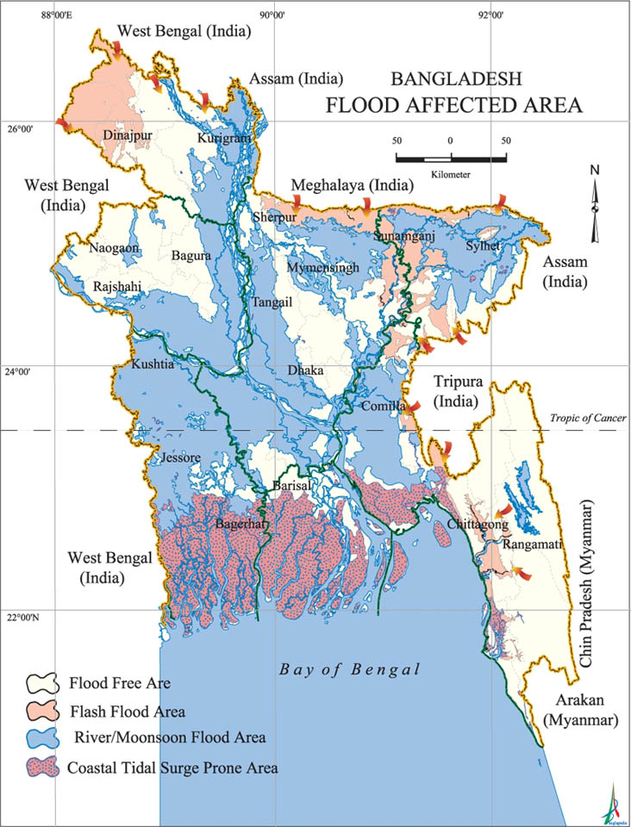
The above-mentioned future climate risks in terms of an increased occurrence of high-intensity floods will have severe implications on household welfare across the floodplains. For both climate variability and climate change, around 80% of total losses fall directly on household consumption (cumulative total consumption losses of US$441.7 billion and US$104.7 billion for climate variability and climate change respectively). Per capita consumption will fall for both farm and nonfarm households. It is argued that women in the affected villages are the primary victims of indigenous coping strategies being employed during floods: they suffer from malnutrition as a result of drastically reducing their food intake when the opportunity for selling labor of the dominant male in the household is decreased during a high flood. This is more prevalent in the greater Rangpur region (particularly in Kurigram, Nilphamari and Gaibandha districts – all of these are project target areas), where the extent of poverty is still very high. Kurigram is a case in itself. It is argued that the District is crisscrossed by at least 16 rivers and is very highly susceptible to flood, which is why the region faced acute poverty.
PKSF has designed the “Extended Community Climate Change Project- Flood (ECCCP-Flood)” to increase the resilience of the poor, marginalized and climate-vulnerable communities towards the adverse effects of climate change in flood-prone areas of Bangladesh and submitted to the Green Climate Fund (GCF). The GCF Board has approved the project in 2020. The project has been contributing to achieve three impact areas of the GCF i.e. 1) increased resilience and enhanced livelihoods of the most vulnerable people, communities and regions; 2) increased resilience of health & well-being, and food and water security and 3) Increased resilience of infrastructure and the built environment to climate change. Major adaptation activities that have been implementing at the community levels in the flood-affected areas are: cluster-based homestead plinth raises, reconstruction of resilient houses on raised plinths, construction of climate-resilient sanitary latrines, installation of tube wells, goat/sheep rearing in slatted houses, climate-resilient crop cultivation etc.

- Project brief
Goal: The goal of the project is to increase the resilience of the poor, marginalized and climate-vulnerable communities towards the adverse effects of climate change in flood-prone areas of Bangladesh.
The Project Participants
The project has targeted 20,000 flood-vulnerable households that will cover approximately 90,000 people. The project has developed selection criteria for the project participants during the design phase. These are:
- Those who are living in riverine char and low-lying flood vulnerable areas;
- Priority on women-headed households and other disadvantaged groups;
- Poor and Ultra-poor Households (as defined in the Household Income and Expenditure Survey (HIES 2016) of the Bangladesh Bureau of Statistics (BBS-2017));
- Daily income is less than USD 1.75;
- Those who are not receiving any support from other projects or organization;

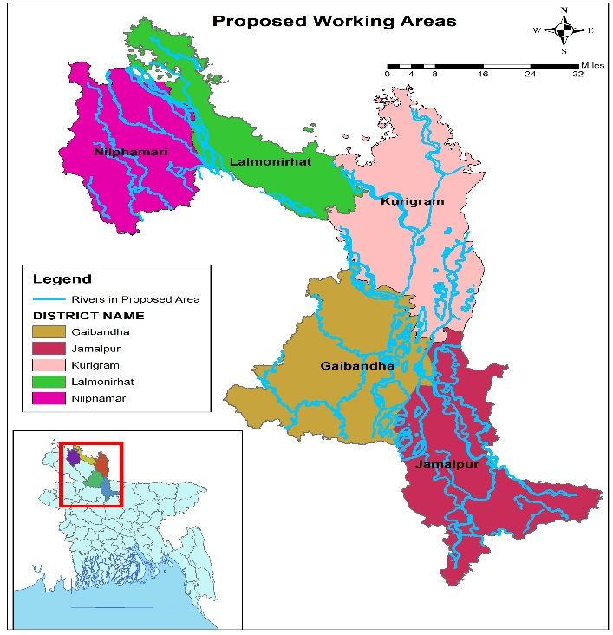
Project working area
The project will be implemented in 5 flood-vulnerable districts namely Nilphamari, Lalmonirhat, Kurigram, Gaibandha, and Jamalpur. The districts have been selected based on two criteria i.e. intensity and frequency of flood and density of poverty.

Expected Outcomes of the Project
The project has identified four outcomes that will contribute to achieve the selected impact areas of GCF (paragraph 2) through the achievement of the project goal.
- Institutions and community groups strengthened capacity on addressing climate change
- Protection of homestead from the adverse effect of flood
- Increased access to safe water and sanitation
- Access to flood-resilient livelihood.

- Overall progress
3.1.Project Management Unit (PMU) Establish
PKSF singed FAA with GCF on 27 April 2020. Immediately after signing the FAA PKSF set up the PMU of ECCCP-Flood project at PKSF Bhaban (building) with all supporting equipment and facilities. Four out of 5 PMU staff have already been recruited all are male. Recruitment of other one staff is under processing.
3.2.Inception workshop:
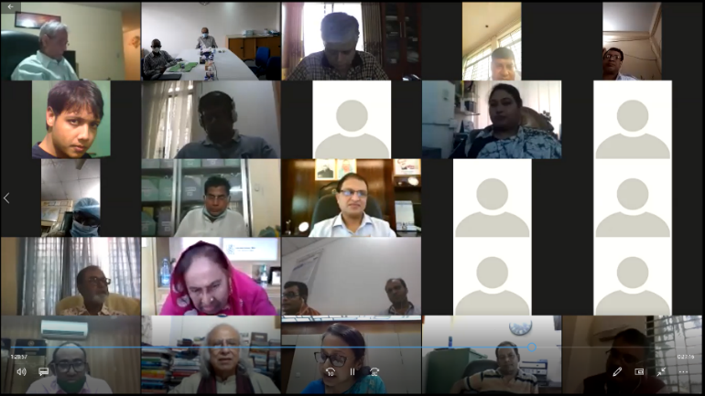

A virtual inception workshop of the project was held on 20 August 2020. Ms. Fatima Yasmin, Secretary of the Economic Relations Division, Ministry of Finance was present as the Chief Guest. It was presided over by PKSF Chairman Dr. Qazi Kholiquzzaman Ahmad and Dr. AKM Rafique Ahammed, Director General, Department of Environment was the Special Guest: Mr. Mohammad Moinuddin Abdullah, the Managing Director of PKSF, delivered the welcome remarks, and Dr. Fazle Rabbi Sadeque Ahmed, Director (Environment and Climate Change) made a brief presentation on the project. The ECCCP-Flood project will strengthen the adaptation capacity and increase the resilience of marginalized communities in 5 flood-prone districts. Two lac people are expected to be benefitted from the project. The major activities of the project include raising homestead plinths, cultivating flood-resilient crops, installing tube-wells and flood-resilient sanitary latrines, livestock rearing, etc. The speakers in the workshop expressed their hope that the ECCCP-Flood project will also provide significant co-benefits - such as improved health, food security, gender equality, women’s security, etc. that can help to adapt to the impacts of climate change and contribute to the green recovery. More than 200 participants, including representatives of various ministries, departments, directorates, Deputy Commissioners of five districts, members of PKSF Governing Body, representatives of various non-governmental organizations and development partners, Executive Directors of PKSF POs, and senior officials of PKSF, attended the webinar.

3.3.Implementing Entity Selection

After signing the agreement with GCF on April 27, 2020, PKSF called for Expression of Interest (EoI) in 4 national dailies on May 20, 2020, for selection of Implementing Entities (IEs). At the same time, a Project Evaluation Committee (PEC) was formed to assess the EoIs. The committee members have reviewed the EoIs based on the set criteria of IE selection.

A five-member Proposal Evaluation Committee was formed to assess the submitted proposal of the potential IEs. The committee prepared recommendations for assessing the applicability and quality of the proposed proposals that have been submitted by the NGOs. The 1st, 2^{nd,} and 3rd meetings of the PEC were held on 15th June 2020, 08th July 2020, and 22nd July 2020 in PKSF Bhaban. The three meetings were chaired by Md. Fazlul Kader, Deputy Managing Director. Mr. K.M. Marufuzzaman, Project Coordinator of ECCCP-Flood and Manager is the Member Secretary. The members of the Committee included Dr. Fazle Rabbi Sadeque Ahmed, Director, Environment and Climate Change Unit; Dr. Akand Md. Rafiqul Islam, Sr. General Manager (Operations) and Mr. Md. Abu Nashir Khan, Assistant General Manager of PKSF. After reviewing the 29 proposals as per the selection criteria of project documents nine NGOs were primarily selected for the ECCCP-Flood. After reviewing and incorporating the feedback of the PEC, the list of NGOs was sent to the Managing Director of PKSF for final approval.
The selected Implementing Entities are ;
- Eco-Social Development Oranization (ESDO).
- National Development Programme (NDP)
- Society for Social Service (SSS)
- Thengamar Mohila Sobuj Sangha (TMSS)
- NAZIR ( Notun Zibon Rochi)
- Padekkhep Manabik Unnayan Kendra (PMUK)
- Gram Bikash Kendra (GBK)
- Self-Help and Rehabilitation Programme (SHARP)
- Peoples Oriented Programme Implementation (POPI)
3.3.Grant Agreement Signing
ECCCP-Flood project was awarded to 09 IEs. The total IEs are previously working with PKSF as Partner Organizations (POs). The grant agreement signing between PKSF and POs took place in November 2020. Mr. Md. Fazlul Kader, Deputy Managing Director was signed on behalf of PKSF and Executive Director from POs were signed from other parts. After signing the agreement PKSF disbursed 12.5% of the total agreed budget of each IE as an advance.
3.4.Recruitment of IEs staff
The project has selected nine Implementing Entities (IEs) following the criteria describing in the FFA for implementing the activities. All the IEs have nominated the focal point officer for this project. Most of the case the focal point officers are senior and permanent staffs of the respective IEs. IE completed the recruitment of necessary project staff. Total 80 staffs were recruited of whom 07 are female. The project personnel are fully deployed in the project area and working to achieve the goal of the project.

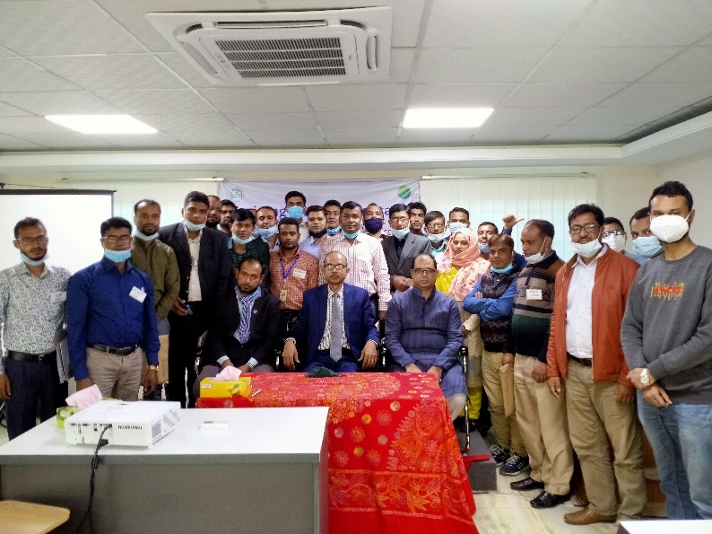
3.5.Training to IEs’ Staff on Project Management: After signing the agreement with IEs, they have recruited project staff for implementing the Project. As per the plan of the project, PMU has organized three days long training for the IEs staff. The Managing Director of PKSF inaugurated the training programme by weibaner. The venue of the training course at ESDO Learning and Resource Centre, Adabar, Mohmmadpur, Dhaka. A total of 80 IEs staff has received training where 7 are female. Under this training course, the IEs staff has learned about project management and operations, procurement, financial management, etc. After completing the training course the participants has gathered knowledge about implementing processes of the project activities, the climate change issues, selection of programme participants, Social Mapping, Environment, and Social Compliances, Procurement guideline, Finance and Accounts etc. After completion of the training course PKSF has provided a certificate to the participants.

3.6.Beneficiary selection and group formation:
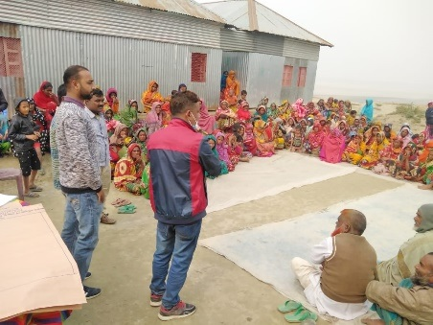
By following the criteria, the IE selected the beneficiary from the vulnerable people and formed the group. The female-headed households and other disadvantaged individuals received priority while selecting the beneficiaries. The beneficiaries were selected through series of consultations with local government, non-government representatives, and local peoples following the trickledown process (e.g., district-level consultation identified the most vulnerable Upazila, Upazila consultation meeting identified the most vulnerable unions, talks at the union level identified the most vulnerable villages). The project selected 19509 households which represent 87790 beneficiaries (target-90000 beneficiaries), whereas 19214 households are female-headed and 295 households are male-headed. A significant person with a disability is included in the project. The number of person with a disability is 52. . Overall 97.5% target was achieved during the reporting period.
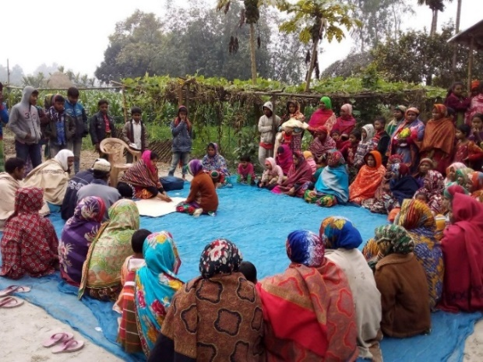
3.7.Climate change adaptation groups (CCAG) formed and operationalized
Focusing on climate change mitigation alone will not be enough for becoming climate-resilient. The project already experienced climate change's adverse effects and made their territories more resilient to its impacts. To foster the exchange of views, knowledge and experiences on key issues around adaptation to climate change, the project has planned to form and operationalized Climate change adaptation group (CCAG). The project already has formed 889 CCAG (88.9% of the total target) consisting of one beneficiary from each household. The groups will take necessary decisions in addressing climate change impacts by the project interventions. The CCAG groups will arrange a monthly meeting to generate an accurate picture of adaptation challenges and possible solutions at the local level. So far a total of 3059 CCAG group meetings have been conducted where in total 68731 females and 1720 are males attended. These groups explore possibilities for local practitioners to consider mitigation and adaptation in an integrated way while finding solutions to mobilize much-needed political and financial support. They will decide who will get what types of support from the project, based on their needs.
3.8.Preparation of vulnerability assessment and adaptation action plan
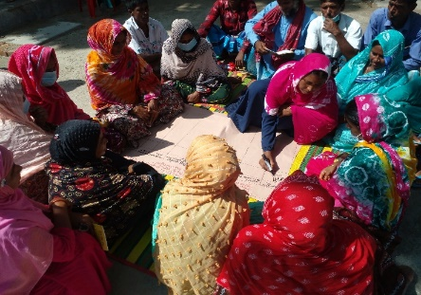
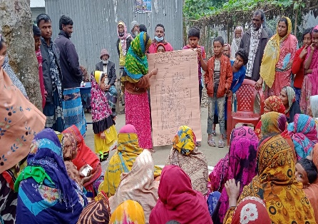
A systematic participatory vulnerability assessment is carried out in each community to increase the understanding of climate change impacts on lives and livelihood. The vulnerability assessment also comes out with long-term planning in the adaptation sector as part of capacity building training to the vulnerable community to address future climate change impacts and vulnerabilities by themselves. In this regard, the IE's staff developed the necessary tools with technical support from PMU. The field-level staff of selected IEs provided training on participatory vulnerability assessment to facilitate the CCAGs to carry out this exercise. A sum of 751 CCAGs are prepared 751 adaptation action plans for their locality during this period. This will enhance their knowledge and understanding of adaptation activities and help reducing loss and damage to their resources and productions. Thus, this activity will contribute to enhancing their resilience to climate change. In addition, it is expected that the selected community will internalize the perception of climate change through this process to address it in the long run.

3.9.Trainings and workshops on Climate Change conducted for beneficiaries and stakeholders
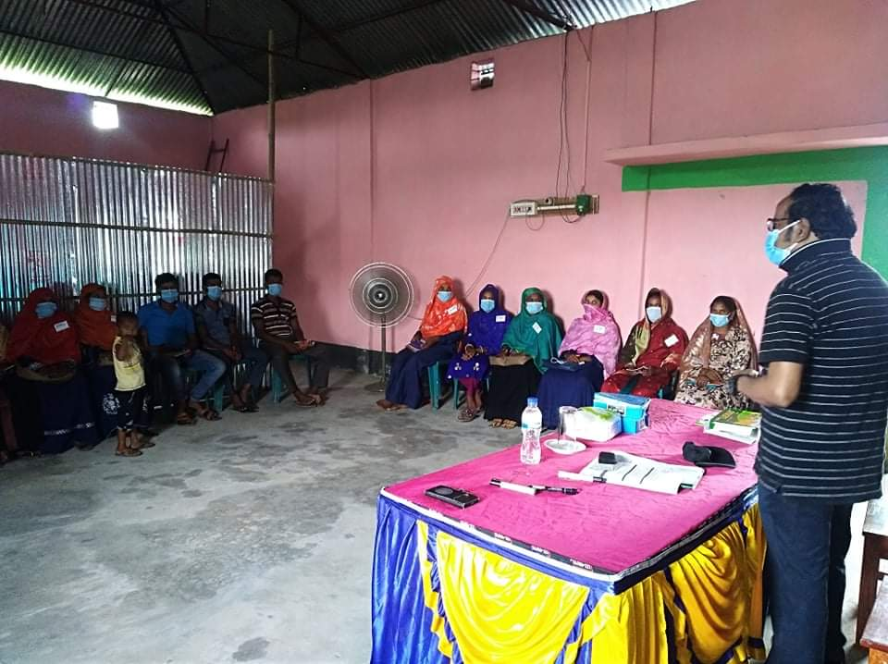
To enhance climate change action, the project organized seven workshops and seminars for Government representatives, development partners, civil society representatives, IEs, etc. Through this, the project reached 718 beneficiaries whereas 526 individuals were female and 192 were male. In addition, PMU has organized three batches of training for the newly recruited staff of the IEs. The duration of each training was three days. The training focused not only on climate change issues but also on project activity, selection of beneficiaries, social mapping, environment, and social compliance, etc. Through this, the project is expected to significantly contribute to strengthening the community-level institutions in addressing climate change issues.
The project provided 30 batches of training on the extension of high-value agricultural technology in the flood-prone area whereas, 711 beneficiaries are attended whom 682 are females and 29 are males . Experts of the agricultural department facilitate the training. During the training, flood-tolerant crops especially rice and guava seeds were provided to the beneficiaries.The provided rice can submerge in water for 15 days. This knowledge helps to initiate the practice to cultivate flood-tolerant crops and they could ensure food security.

Rearing the goat in the slatted house and vaccination process also incorporated in the training. Slatted house, vaccination process has already initiated. With this, disease, as well as the mortality rate of goats, is expected to decrease. The project provided training on goat/sheep rearing to 390 beneficiaries whom 388 are female. Besides this project has a grant for the slatted house and also provided the loan for buying goat/sheep. Moreover, the household's economic condition will increase, which will help them in adaptation in the face of a flood.

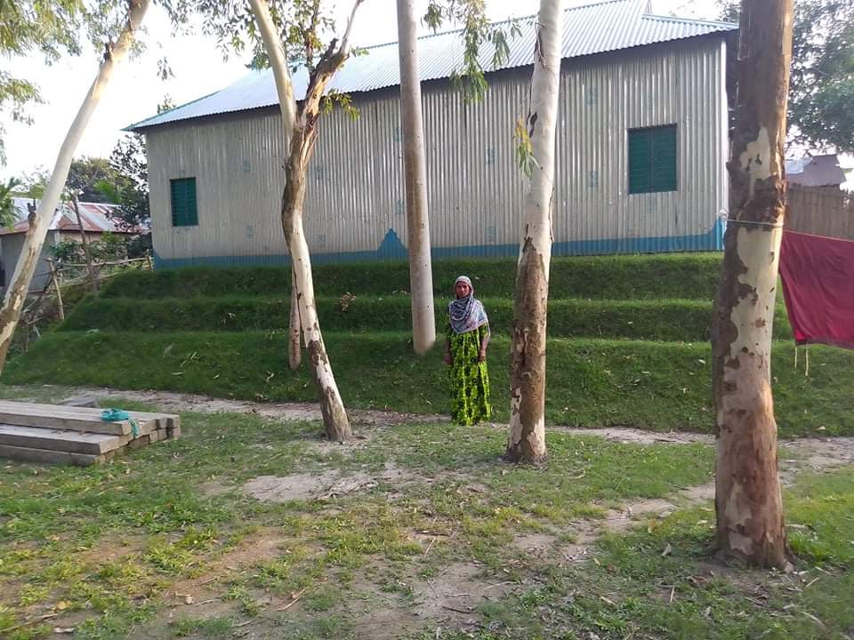
3.10.Raised homesteads above flood level
Homesteads have been raised by the project support for protecting the beneficiaries from being damaged by the flood. It also provides emergency shelter during flooding. This project has already raised the plinth of the 1750 homesteads (17.5% of its project target) whom 1742 are female HHs. The life for those families has now stabilized. A cluster-based approach was adopted and successfully implemented for raising plinths. Beneficiaries now could grow fruit and vegetables on their homestead and sell the products in the market. So that their family income will increase. The raised plinth is also helpful to nurture the domestic animals at the same time life savings especially during the flooding period.
Photo: Raised homestead above flood level
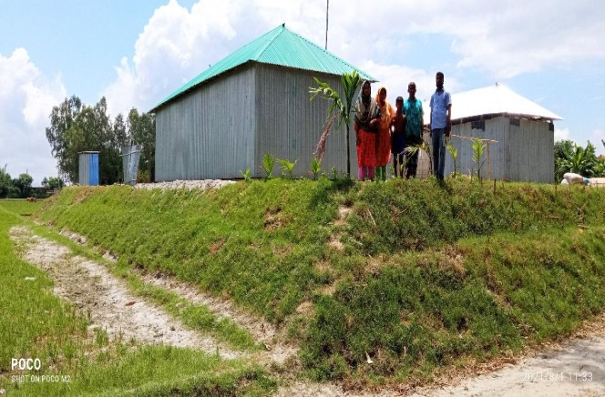
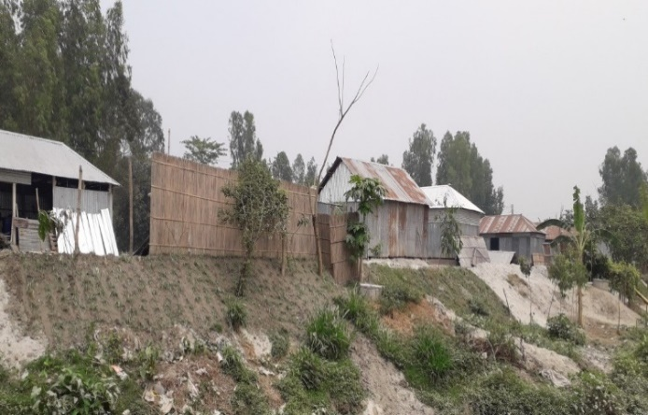
Along with the homestead-raising, tube-well and sanitary latrine will also provide to increase the resilience

3.11.Reconstruction of climate resilient houses
Construct a safe and resilient house can help protect lives and livelihoods from disasters and build sustainable communities. The ECCCP-flood project also promotes resilient houses to save and improve lives, protect assets, and shield economies from increasing disaster risks. Considering the future climate variability and extremes, the project provided financial support to 9 households as a credit to reconstruct the climate-resilient house on the raised plinth, the reconstructed houses would be strong enough to stand in the face of any climatic stressor.

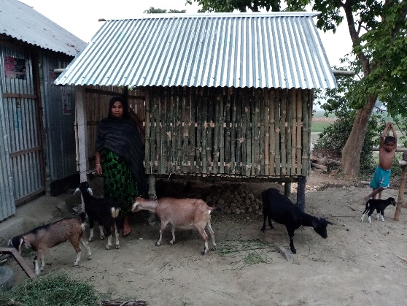
3.12.Provide support to rearing of goat/sheep in slatted houses

Goats and sheep are multipurpose animals that can produce meat, milk, fiber, and manure and are also very versatile. So raising those animals is so helpful and profitable and increases the resilience of the livelihood. Proper housing of goats and sheep as a component of one of the major management practices is equally important as goat rearing to thrive out their production performance to the full potential. Environmental factors such as heat, humidity, rain, and wind can stress goats, depress their immune system, and lead to either parasitic or respiratory problems, which can be fatal. Slatted house is necessary for staying at night, security from being theft, and protected from deadly diseases and preventing them from adverse climatic conditions like direct exposure to sunlight at noon during the summer season, cold stress and heavy rain. Goats and sheep can tolerate cold weather and heat as long as they live in a slatted house.
To avoid the effect of the different diseases of goat/sheep the project provided support to 390 households to rear goat/sheep in slatted houses whom 388 are female. As a result, the growth and reproduction of goat/sheep are expected to increase as well as total production. We need to mention that we selected a dry and higher place in raised plinth homestead’s courtyard to make the slatted house so the area is high enough to keep the goats safe from floods.

Besides, nine households have received financial support to purchase goats and sheep to prosper their livelihood. Overall, such activity motivates the other community people to rear the goat/ sheep and has a significant impact on the socio-economy of the community.

- Progress by Indicators:
 | Description | Indicators | Baseline | Achieved (Till 2021) | Targets | Targets
 |  |  |  |  | (mid-term) | (final)
Objective related to GCF RMF Impact Areas | Increased resilience of the poor, marginalized and climate vulnerable communities towards the adverse effects of climate change in flood prone areas of Bangladesh | Increased capacity and awareness of local institutions and communities | 0 | 45% total | Beneficiaries: 10% slightly increased resilience, 60% moderately increased resilience and 15% highly increased resilience | Beneficiaries: 5% slightly increased resilience, 50% moderately increased resilience and 30% highly increased resilience
 |  | Practiced climate resilient farming | 0 | 0 | 15,000 farmers | 20,000 farmers
Outcomes | Outcome 1: Institutions (IEs) and community groups strengthened capacity on addressing climate change | Increased capacity of NGOs to support households in flood protection and dissemination of adaptation solutions | 0 | 0 | 2 slightly increased capacity, 5 moderately increased capacity and 3 highly increased capacity | 1 slightly increased capacity, 5 moderately increased capacity and 4 highly increased capacity
 |  | Increased capacity of households to apply climate change adaptation solutions | 0 | 0 | 10% slightly increased capacity, 60% moderately increased capacity and 15% highly increased capacity | 5% slightly increased capacity, 50% moderately increased capacity and 30% highly increased capacity
 |  | Utilization of the knowledge from the knowledge products | 0 | 0 | Institutions: 3 slightly, 6 moderately and 1 highly utilize knowledge from the knowledge products | 1slightly, 5 moderately and 4 highly utilize knowledge from the knowledge product
 |  |  |  | 0 | Beneficiaries: 20% slightly use, 40% moderately use and 5% highly use knowledge from knowledge products | Beneficiaries: 30% slightly use, 30% moderately use and 10% highly use knowledge from knowledge products
 | Outcome 2: Protection of homestead from adverse effect of flood | Reduced economic losses in animal husbandry | 1.26 million USD (annual average in Rangpur division, BBS, 2015) | 0 | Reduction of loss by 50% on targeted beneficiaries | Reduction of loss by 90% on targeted beneficiaries
 |  | Increased income and nutrition uptake of the communities due to raising homestead plinths | Income: monthly BDT. 3,573 (42.54 US$) (CCCP baseline) | 0 | Increased Income: 20% | Increased Income: 30%
 |  |  | Nutrition: 47.91% sickness due to flood | 0 | Nutrition: reduced sickness by 5% | Nutrition: reduced sickness by 10%
 |  | Increased women’s security during flood | 0 | 0 | 10,000 slightly secured, 20,000 moderately secured and 15,000 fully secured from sexual harassment during flood | 5,000 slightly secured, 15,000 moderately secured and 25,000 fully secured from sexual harassment during flood
 | Outcome 3: Increased access to safe water and sanitation | Percentage of population in the targeted areas with access to safe water | 72.6% (CCCP baseline) | 0 | 85% of the targeted beneficiaries | 90% of the targeted beneficiaries
 |  | Percentage of population in the targeted areas with access to flood resilient sanitation | 9.1% (CCCP baseline) | 0 | 60% of the targeted beneficiaries | 80% of the targeted beneficiaries
 | Outcome 4: Access to flood resilient livelihood | Increase in household income in targeted households by practicing GCF funded livelihood technologies | Monthly BDT. 3,573 (42.54 US$) (CCCP baseline) | 0 | 30%  (increased income) | 40%  (increased income)
Outputs | Outputs related to Outcome 1
 | Output 1.1 Climate change adaptation groups (CCAG) formed and operationalized | Number of climate change adaptation groups formed and operationalized | 0 | 889 | 1,000 | 1,000
 |  | Improved capacity of climate change adaption groups related to knowledge management and information dissemination | low |  | moderate | high
 |  | Impact of the meetings on the decision-making process | Low effective |  | Moderately effective | Highly effective
 | Output 1.2 Preparation of vulnerability assessment and adaptation action plan | Number of vulnerability assessment and adaptation plans | 0 | 751 | 1,000 | 1,000
 |  | Percentage of vulnerability assessment and adaptation plans used in decision making and planning by households or IEs | 0 | 0 | 40% | 60%
 | Output 1.3 Trainings and workshops on Climate Change conducted for beneficiaries and stakeholders | Use of the information from the trainings and workshops in decision-making and planning at household or policy level | 0 | 0 | 40% of the targeted beneficiaries use the information from the trainings and workshops | 60% of the targeted beneficiaries use the information from the trainings and workshops
 | Output 1.4 Preparation and dissemination of knowledge products | Quarterly newsletter published | 0 | 0 | 7 | 14
 |  | Number of workshops organized | 0 | 0 | 10 | 20
 |  | Lessons learnt published | 0 | 0 | 0 | 1
 | Outputs related to Outcome 2
 | Output 2.1 Raised the homesteads above flood level | Number of homesteads constructed | 0 | 1750 | 6,000 | 10,000
 | Output 2.2 Re-construction of climate resilient houses | Number of resilient houses constructed | 0 | 0 | 6,000 | 10,000
 | Outputs related to Outcome 3
 | Output 3.1 Installation of resilient tube wells | Number of tube- wells installed | 0 | 0 | 300 | 500
 |  | Percentage of tube-wells providing water by ensuring national standards | 0 | 0 | 60% | 80%
 |  | Number of beneficiaries using safe water (gender disaggregated) | Male 0 | 0 | Male 3,000 | Male 5625
 |  |  | Female 0 | 0 | Female 3000 | Female 5625
 |  | Decrease in water-borne diseases | Annual average 23,374 persons in selected 5 districts become sick due to lack of access to safe water (calculated from BBS, 2015) | 0 | 50% of the targeted beneficiaries | 80% of the targeted beneficiaries
 | Output 3.2 Construction of sanitary latrines | Number of sanitary latrines constructed | 0 | 0 | 1600 | 2,810
 |  | Number of beneficiaries using sanitary latrines (gender disaggregated) | 0 Male | 0 | 3600 female | 6,325 female
 |  |  | 0 Female |  | 3600 male | 6,320 male
 | Outputs related to Outcome 4
 | Output 4.1 Rearing of goats/sheep in slatted houses | Number of beneficiaries reared goat/sheep in slatted houses | 0 | 390 | 6,000 women beneficiaries | 10,000 women beneficiaries
 | Output 4.2 Cultivation of flood tolerant crops | Increase in crop production | Baseline to be provided in inception report | 0 | 30% increase | 40% increase
 |  | Number of farmers cultivating flood tolerant rice crops | 0 | 0 | Female 2000 | Female 3000
 |  |  |  | 0 | Male 2000 | Male 3,000
 |  | Number of farmers cultivating short duration and disease protective wheat varieties | 0 | 0 | 1,500 beneficiaries | 2,000 beneficiaries
 |  |  |  | 0
 |  | Number of farmers cultivating vegetables in the sand bars | 0 | 0 | 1,500 women beneficiaries | 2,000 women beneficiaries

Field visit by the PMU members
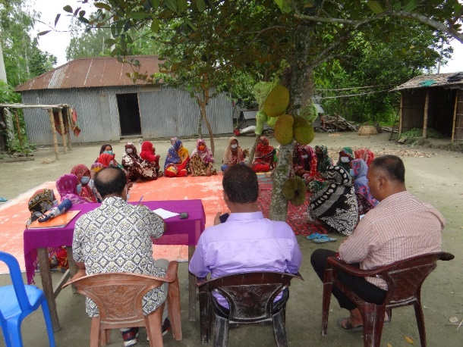
PMU has already conducted eight field visits of 5 days each in the respective areas to oversee the Implementing Entities (IEs) actions. The objective of the visit was to ensure whether the IEs’ staff were selecting appropriate villages and project participants following the criteria stated in the FAA. It was found that overall the project staff properly selected the beneficiaries. Few of the selected beneficiaries were found less vulnerable because they have other small businesses which are less sensitive to climate change. Their income level is also higher than the project specified criteria. PMU staff provided the necessary guidance to address this gap. Besides, based on the field visit, PMU sent a letter to each IE was providing detailed suggestions and guidance in Bangla. In addition, the Director of the Environment and Climate Change unit of PKSF has visited the working areas. The Director also provided verbal and written guidelines and suggestions to the IEs.
The PMU has prepared a simplified procurement guideline for the staff of the implementing entities. The PMU also provided training to the staff on this guideline. In addition, the PMU staff visit the field offices of the implementing entities and providing them on-the-job training on procurement goods, services and works at the field level.

- Status of ESS implementation:
  - PS1: Assessment and Management of ESS risk
The ECCCP-Flood project follows all compliances of performance standards 1 to 8. Performance standard 1 was carried out during the design phase of the project. As per the assessment, the project was categorized C as per the GCF standard of category. The project has prepared a comprehensive plan for continuing close monitoring of all potential mitigation measures management during the project period. As planned, Environmental and social monitoring is ongoing through pre-designed monitoring formats and checklists as appropriate during the project period. During the reporting period, plinth raising was the only tangible activity in the field. It was found that the sandy sediments were used to raise plinths of the homestead area. The earth collection points are naturally filled with sediments during the monsoon. No additional efforts were required to manage the earth-collection points. Overall, all the compliance issue is ensuring according to the guideline and standard through the routine monitoring.
  - PS2: Labour and working conditions
Good worker-management relationship, and treating the workers fairly and providing them with safe and healthy working conditions create tangible benefits, such as enhancement of the efficiency and productivity of the intervention. Comply with national employment and labor laws PKSF and its IEs implement the project in its intervention area to ensure fair treatment, non-discrimination, equal opportunity of the beneficiaries. Minimum PPE requirements for the project have been ensured to protect the beneficiary’s eyes, face, hands, feet and in concern with that the IE’s arranged and oversee the supplies as well as uses of following PPE. The IE’s provided hand wash materials, as a part of ensuring the safety security of the project. All the beneficiaries wore masks during raising homestead plinths. They additionally used long shirts and full pants. As no injuries were reported during this period but first aid box has been ensured and placed at the implemented area for ensuring the primary health care services in the emergency which included liquid antiseptics like Dettol/savlon, cotton, bandage, etc.
  - PS3: Resource efficiency and pollution prevention
The IE’s have carried out earthwork for homestead plinth raise during the reporting period but they do not keep many options for blowing. Beneficiaries used water to minimize windborne particles and fugitive dust during work. As most of the fallow lands are covered by grass and some are exposed,In that case, beneficiaries focused on the exposed area especially excessive presence of crumbly soil or sand dominant soil, to water during activity. Besides, Regular monitoring and supervision will conduct to ensure to minimize fugitive dust pollution.
  - PS4: Community health, safety and security
Though this intervention has the insignificant potential for community exposure to risks and impacts arising from accidents, burning fuel, and releases of hazardous materials, it already brought out benefits to communities including employment, opportunities for economic development and increase the resilience of the community. Overall, the project is not responsible for Community health, safety, security to a large extent. Besides, no issues were identified and reported during the reporting period.
  - PS5: Land acquisition and involuntary resettlement
Potential impacts to the project location have been considered during the project planning stage. As there is no issue of land acquisition and involuntary resettlement hasn’t been included in the project plan so there is no displacement issue neither the forcefully eviction has happened yet. If it happens, we will go for an alternation project design and share it with the GCF authority.
  - PS6: Biodiversity conservation and sustainable management of living natural resources
Project areas are covered with great numbers of specific vegetation other than nominal roadside trees, with some secondary growth trees and shrubs. There are no forests, no evidence of the wildlife of the higher species are observed in the vicinity of implementing area. Besides, there are also no rare, endangered, sensitive species reported in the assessment report. The IE’s were kept away from extracting topsoil, forest, wetland as earth cutting points for plinth raising. During the activity of the plinth, raising soil is taken from the nearest fallow land or ponds of the household. In the char areas, the soil is available from the nearest source of the river so there is no excuse for to loss of agricultural soil. The project provided training on IPM and preparation of organic pesticides to the beneficiaries. Besides, IE’s also provided training on cleaning of goat/sheep shed, disposal and dumping of goat/sheep fecal matter to nearby safe dumping/collection corners, making compost/slurry management. Besides, Awareness of beneficiaries on odor, insects and mosquito breeding, cleaning of goat/sheep shed organic pest control technique such as NEEM dust, Light trapping, etc has been conducted in the group meeting. Furthermore, discussion on using pest management, vermin-compost and organic pest control was also incorporated in the CCAG meeting. The IE’s Staff will continue to monitor the progress of training output. Through this, the project has focused on biodiversity conservation and ensured the sustainable management of living resources
  - PS7: Indigenous peoples
As the project has full respect for the rights, culture, livelihood, knowledge and practice of indigenous people but still the project did not find any indigenous people within the implementation area.
  - PS8: Cultural heritage:
As there is no cultural heritage are found in the project area during the assessment so there is no issue of protection and preservation of cultural heritage.
- Gender perspective:
The project is well aware of gender mainstreaming. Hence, the project has taken a gender-responsive and transformative approach to climate change vulnerability, considering gendered differences in access to resources, ability to pursue adaptive livelihoods, and institutional support and capacity building, and this has fundamentally shaped all of the activities and outputs of the project. The project recognizes women’s essential contributions as leaders and agents of change in the face of a changing climate and resource constraints. As competent females were not found at AE level but at the IE level, 7 staffs out of 80 are female which is 8.75% of the total staff. Overall, this project has already plan to engage the female in each activity. Female beneficiary has also given priority at the beneficiary selection criteria. The project provided financial support to 7 female-headed households to purchase goats and sheep The project already targeted to reach 80% of women CCAG members and also incorporated in the plan. The project believes that the empowerment of women is the key to sustainable development in the country.
- Grievance mechanism:
Sometimes, verbal complaints are raised between the earth workgroup. In those cases, responsible IE’s staff contact them and trying to mitigate that conflict by arranging social discussion. Beneficiaries don’t show interest in preparing slopes, because they thought this type of slope has decreased their land. IE’s staff motivated them and make them realize that slope is important to ensure the sustainability of the plinths. It is to be mentioned that some people claim that they should be included in the list of the project participants. It is mainly due to lack of information about the criteria of the project participants. When the IE staffs explain these criteria, they understand and withdraw their complaints. These complaints are not written because the aggrieved person does not want to make written complaint. We have also lacked in building the capacity of the IEs’ staff in terms of providing training for documenting the grievance.

- Challenges
- Due to the COVID-19, it will be difficult to 100% achieve the pre-agreed numbers of budgeted activates. Though, COVID-19 infection rates across Bangladesh gradually decreased in the last few months, which is a sign that the overall COVID-19 situation in the country is within control.
- Currently, there is a lack of specialized staff on public procurement at the local level.
- It seems that IEs staff drastically switching the job. Every time, new staff required training. Frequently providing training and making them knowledgeable in a short time is sometimes critical.
- Most of the project area is situated in remote areas. So field visits would be difficult. So, the Communication gap has happened.
- Due to COVID-19, necessary training couldn’t provide to IEs staff and the beneficiary. Lack of project knowledge could hamper the service quality of the project.
- It seems that IEs couldn’t adapt the procurement guideline. So they couldn’t practice it properly at the local level.
Lesson learn:
- Every single person in the country is trying to adapt to the ‘new normal’ situation and PKSF is also adjusting its plan as per the prevailing COVID-19 situation. PKSF is also trying its level best to keep the IE’s motivated under this current situation so that they can perform the activities effectively and efficiently.
- At the same time, PKSF is also educating them on how to conduct the activities by maintaining the hygiene rules and social distancing so that the community and the IE staff can remain safe and in good health and the main objective of the project can the achieved within the stipulated time frame.
- However, in the coming years, we will make sure we overcome the shortfall in coming years that we have faced in year 1 so that we achieve the target agreed as per agreement.
- Additional training is required regarding procurement guideline and enforces them at the local level.
- The IEs concern needs to focus on staff retention.
- To overcome working in the remote area and reduce the challenge, some IEs already set up a new office in their implementing area.
- Proper training regarding the Complain grievance mechanism needs to conduct soon.

- Way forward
- Beneficiary selection will be completed within the next reporting period. The rest of the CCAG group is expected to be formed and operationalized. The PMU will publish a newsletter very soon.
- Hopefully, Installation of tube-well and construction of sanitary latrine will be initiated.
- The IEs staff will select the farmers based on pre-defined criteria in consultation with CCAG members.
- PMU reviewed the work plan and implementation will be ensured according to the workplan.
- A baseline evaluation along with an RBM study will be conducted and extracted findings and lesson learned will incorporate in the project.
- Special training will be arranged on ESS, gender, grievance mechanism.
- Formal training will arrange within the beneficiary selected CCAG group from PMU.
- Field visit will increase as well as close monitoring and supervision which was halted due to the lockdown of the pandemic situation.
- Training will be held on the procurement plan to reinforce it at the local level.

This document defined extreme poor as the person having purchasing power parity (PPP) below 1.25 USD a day and PPP below 1.90 a day is called poor.

