SAP008 “Extended Community Climate Change Project-Flood (ECCCP-Flood)”
Monitoring Report

Field Visit Report

PKSF is implementing a Project titled Extended Community Climate Change Project-Flood (ECCCP-Flood) in the five most flood vulnerable districts in Bangladesh. The implemting districts are Kurigram, Nilphamari, Lalmonirhat, Gaibandha and Jamalpur. Based on the food security and intensity of the flood the project will be benefitted 90,000 people (20000 HHs). The duration of the project is 04 years. Major activities of the project are homestead plinth raising, construction of flood resilient sanitary latrine, tubewell, slatted housing system of goat/sheep rearing, flood-tolerant rice cultivation, pumpkin cultivation at sandbar and wheat cultivation.
A team of three PMU members consisted of Mr. Md. Rabi Uzzaman, Deputy Manager, PKSF; Mr. Md. Mahmuduzzaman, Deputy Manager, PKSF and Mr. Enayet Kiyoum, Finance and Account Officer, ECCCP-Flood project visited field level activities of Extended community Climate Change Project from 13-17 June 2021. The team visited activities of three implementing entities i.e. National Development Program (NDP) at Chilmari and Char Rajibpur Upazila (sub-district) of Kurigram district, Eco-Social Development Organization (ESDO) at Fulchory Upazila of Gaibandha district and TMSS at Saghata Upazila of Gaibandha district. The observations found during the visit are presented below:
- National Development Program (NDP)
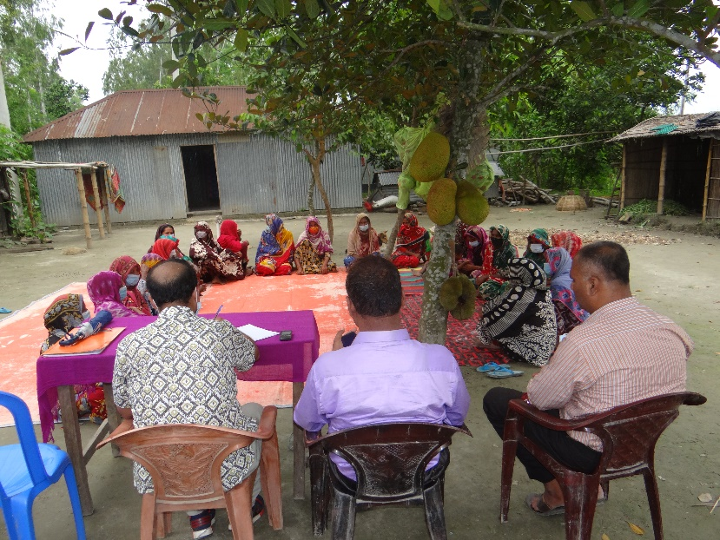
Description of the project and working area: The NDP is implementing the project at Chilmari and Char Rajibpur Upazila of Kurigram district. NDP covered four unions (the lowest administrative unit in Bangladesh) including Chilmari Sadar, Ramna and Nayarhat of Chilmari Upazila and Kodalkathi of Char Rajibpur Upazila. The areas are riverine char lands and situated in the river of Brahmaputra. Consultations with the local communities reveal that the settlements of this area get inundation by flood almost every year. The flood-affected people of this area lose their agricultural crops, livelihoods assets and homestead vegetables. Besides these, they take shelter on the river bank and flood shelter. Most of the people depend on agricultural day labourers, fishing. So, people of these unions are vulnerable to flood and flood-related disasters.
The NDP has targeted to enhance the resilience of 3400 HHs of whom 1700 HHs will receive support for raising homestead plinths, 482 HHs for flood resilient sanitary larine, 85 number of flood resilient tubewells, 1700 HHs for slatted housing for goat/sheep and 880 HHs for flood resilient agricultural crops production.
Observation: We observed during the field visit that NDP selected 487 HHs and formed 16 Climate Change Adaptation Groups (CCAGs) against planned 3400 HHs and 170 CCAGs. The team observed that the selected project area is very hard to reach because the IE selected the most vulnerable villages which are dissected char lands. In addition to the remoteness, the team identified that initially, the IE’s staffs took time to conceptualize the project and transform the concept into action. Besides, the government declares COVID-19 restrictions at different times. So, the activity is falling behind from the plan.
It was found during the visit that the IEs and communities have made significant progress in raising homestead plinths. The team visited Char Sajai CCAG (Char Sajai is a village and the CCAG of this village is named after the village) located at Kodal Kathi union of Char Rajibpur Upazila. The team met four of the CCAG members including Nurjahan, Rowshonara, Rupali and Minara. They raised their homestead plinths with support from the ECCCP-flood project. They followed the Activity Implementation Guideline of the ECCCP-project that was provided by the PMU. The IEs’ staffs helped them understanding these issues in the guideline and ensure that these compliances are duly addressed. During the visit, the team compared pre-measurement and post-measurement of earthwork of the cluster and found that the earth volume is properly claimed. PKSF team visited another cluster of 11 members of the same group. The cluster members are Khadeza, Rahima, Nasima, Sufia, Jobeda, Sokhina, Rabeya, Sahinur, Onjana, Nurjahan and Khusi. Though the height of the plinth of this cluster is raised according to the guideline, the slope was not prepared following instructions. The reason was that the poor people have very limited land. If they maintain the slope as per the guideline, the top area of their plinths is reduced. They are not interested to spread the bottom of the plinth for making slope. But the slope is an important structure of the raised plinth because it saves the plinths from erosion during the flood. The visiting PMU members consulted about the needs of making slope with the community people about the importance of the slope. The team also suggested the IEs field level staffs motivate the project participants for making the slope of the plinth. Similar observations were found in another cluster of Samina, Hafiza and Samsunnnahar.
The team also visited similar activity in another union called Nayarhat. The PMU members visited activities in Kheruar Char village of Nayarhat union of the same IE. A group discussion was conducted with the CCAG members at Kheruar Char village. The meeting discussed about climate change-related problems and how to overcome those. The group members informed that their homesteads would have inundated regularly due to floods. They expressed their happiness due to having raised homestead. They added that that the flood will no more affect them. The team asked why they would not do it earlier. They responded that they did not have the capacity to raise plinths because they mostly live from hand to mouth. It was also found from the consultation meeting that the poor people in char areas usually built Katcha houses on other’s land by taking lease. Interesting condition of the lease is that the lease taker would reside on the land for an undefined period till there is a severe river erosion damaging the area. They pay BDT. 3000-5000 per decimal for lease for lifetime.
PMU team members also visited individual households of the raised clusters. It was found that the participants were not aware of the amount of earth and allocated budget. Though it was shared with them, but they seldom can recall the length and witdh of the homestead. But they know the total expenditure of their specific clusters. The team discussed clusters no. 11 and 12 (randomly selected). Six households are residing on cluster no. 11. The households’ representatives were Khushi, Maleka, Rongvanu, Shahana, Nazma and Majeda. They said that their homesteads were raised at 5.5 feet high which is enough to escape the flood in this area. It was also found that the plinths were raised according to the activity guideline. Other activities had not been started during the field visit. The team observed that some small fruit trees were mostly covered by raised soil. The community people have plan to plant similar trees on the homestead to compensate for these damaged plants.
During the visit, PKSF team checked all documents related to accounts and finance including vouchers and bills. Some important observations are:
- The Accounts Officer provided advance money to the Field Officer without having their signature.
- No signature was found on the debit voucher
- Overwriting were found on the movement register, salary sheet etc.
- The Project Coordinator did not maintain logbook for using Motorbike which means no. movement occurred with his vehicle but the Accounts Officer accounted expenditure against motorbike rent.
At the end of the visit, the PMU team conducted a meeting with IE’s staffs together with their focal person. PKSF team provided different suggestions to IE’s to improve the quality of implementation of the project activities.

- Eco-Social Development Organization (ESDO)
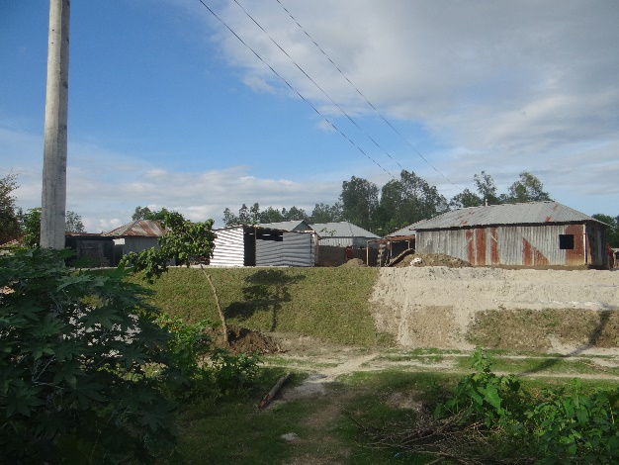
Description of the project and working area: The Eco-Social Development Organization (ESDO) is implementing the project at Motherganj and Sorishabari Upazila of Jamalpur districts and Fulchori Upazila of Gaibandha district. ESDO covered a total of 7 unions (2 unions in Motherganj Sadar, 2 unions in Sorishabari and 3 unions in Fulchori Upazila. Most of the people of the areas are poor, ultra-poor and landless. The vulnerability situation is very similar to the working area of NDA as stated above.
The ESDO has targeted a total of flood vulnerable 5,300 HHs for enhancing their resilience. Among the targeted households, 2,650 HHs will receive support for homestead plinth raise, 743 HHs for flood resilient sanitary larine, 132 HHs for flood resilient tube wells, 2650 HHs for goat/sheep rearing in slatted housing and 2,560 HHs for flood resilient agricultural crops production. It is to be noted that a household will receive more than one supports i.e. plinth raise, tubewell and crop production or plinth raise, sanitary latrines and goat/sheep rearing or crop and tube well and so on.
Observation: PKSF team visited field-level activities in Phulchhari Upazila of Gaibandha district. The team found that ESDO strictly followed selection criteria while selecting the project participants. This IE completed the selection of project participants by the visiting period. They also formed the CCAGs with the selected members. The team found that most of the CCAG members are women. The team observed that the selected project areas are hard to reach which is dissected riverine char lands.
It was found during the visit that the IEs and communities have made significant progress in raising homestead plinths. The team visited Ghatiamari CCAG (Ghatiamari is a village and the CCAG in the village is named after it) located at Fojlupur union of Phulchhari Upazila of Gaibandha districts. The team met 8 CCAG members including Chamili, Sahana, Nurjahan, Onjona, Nosimon, Golap Banu, Asiron and Majeda. They raised their homestead plinths with support from the ECCCP-flood project. They followed PMU-provided guideline and design of the plinth. The IE’s staffs helped them understanding issues and compliances that are included in the guideline. During the visit, the team compared pre-measurement and post-measurement of earthwork of the cluster and found that the earth volume is properly claimed. PKSF team visited another cluster of 10 members of the same group. The cluster members are Monera, Hasina, Amena, Siri, Fatema, Nurjahan, Johiron Alpona, Fulera and Sudhia. They expressed their happiness to have the raised plinth of their homestead. They informed that earlier they could not cultivate vegetables in their homestead areas. Now they are planning to cultivate vegetables. They planned to provide shelter to other flood-affected communities on their raised homesteads.
The team also visited similar activity in another union called Erandabari. The PMU members visited activities in Char Chetmohon village of Erandabari union of the same IE. A group discussion was conducted with the CCAG members at Char Chetmohon village. The meeting discussed about climate change-related problems and how to overcome those. The group members informed the PMU team that their homestead would inundate regularly due to floods. They expressed their happiness due to having raised homestead. They informed the visitors that the flood will no more affect them. The team asked why they would not do it earlier. They responded that they did not have the capacity to raise plinths because they mostly live from hand to mouth.
PMU team members also visited individual households of the raised clusters. It was found that the participants are not aware of the amount of earth and allocated budget. Though it was shared with them, but they seldom can recall the length and width of the homestead. But they know the total expenditure of their specific clusters. The team met with China Begum, Fojol Ali, Momota Begum, Abdul Khalek and Sukithon. They said that their homesteads were raised 6.0 feet high which is enough to escape the flood in this area. It was also found that the plinths were raised according to the activity guideline. Other activities had not been started during the field visit. The team observed that some small fruit trees were mostly covered by raised soil.
During the visit, PKSF team checked all documents related to accounts and finance including vouchers and bills. Some important observations are:
- The Project Coordinator did not maintain logbook for using Motorbike which means no movement occurred with his vehicle but the Accounts Officer accounted for expenditure against motorbike rent.
- They did not properly maintain Public Procurement Rules, 2008 (PPR-2008) for procuring computer and furniture.
- There was no signature on the debit voucher.
- There were many overwriting on the movement register, salary sheet etc.
At the end of the visit, the PMU visitors conducted a meeting with IE’s staffs together with their focal person. PKSF team provided necessary guidance and suggestions to IE to improve the quality of implementation of the project activities.

- TMSS
Description of the project and working area: The TMSS has been implementing the project at Saghata Upazila of Gaibandha district. TMSS covered three unions of Saghata. Most of the people of these areas are poor, ultra-poor and landless. The areas are located in the char areas of the river Brahmaputra.
TMSS targeted 2,000 HHs. Among them, 1000 HHs will receive support for raising homestead plinth, 281 HHs for flood resilient sanitary larine, 50 HHs for tube wells, 1000 HHs for slatted housing for goat/sheep and 1280 HHs agricultural crops among the programme participants.
Observation: TMSS selected 645 HHs project participants and formed 27 Climate Change Adaptation Groups (CCAGs) during the visit period against the planned of 2,000 project participants and 100 CCAGs. The team observed that the selected project area is highly vulnerable to flood because it is located in the dissected riverine char areas of the Brahmaputra River. In addition to the remoteness, the team identified that initially, the IE’s staff took time to conceptualize the project and transform the concept into action. Besides, the government declares COVID-19 restrictions at different times. So, the activity is falling behind from the plan.
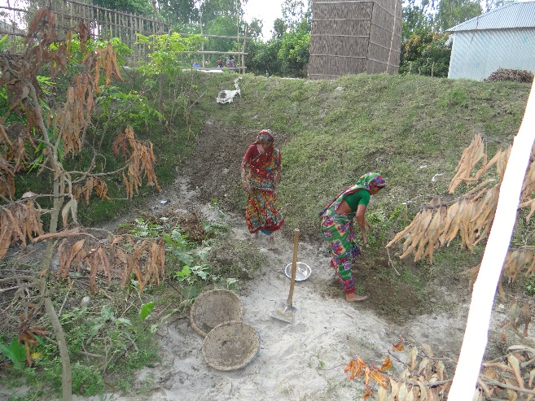
Regarding the physical interventions, the PMU team found during the visit that the IEs and communities have made significant progress in raising homestead plinths. The team visited Hatbari Pansipara CCAG located at Saghata upazila. The team met 7 of the CCAG members including Felani Begum, Omera Begum, Sahera Begum, Jorina Begum, Julekha Begum, Amela Begum and Morseda Begum. They raised their homestead plinths with support from the ECCCP-flood project. They followed the Activity Implementation Guideline of the ECCCP-project that was proved by the PMU. They consider the ESS compliances while raising the plinths. The IE’s staffs help them to understand these issues and ensure that these compliances are duly addressed. During the visit, the team compared pre-measurement and post-measurement of earthwork of the cluster and found that the earth volume is properly claimed. PKSF team visited another cluster of 5 members of the same group. The cluster members are Moriom Begum, Fulera Begum, Bechia Begum, Aisa Begum and Soneka Begum. Though the height of the plinth of this cluster is raised according to the guideline, they did not make the slope as per guideline because of small amount of land. It reduces their house construction area on the top of the plinth. But the slope is an important structure of the raised plinth because it saves the plinths from erosion during the flood. The visiting PMU members consult about the needs of making slope with the community people about the importance of the slope. The team also suggested the IEs field level staffs to motivate the project participants for making the slope of the plinth. Similar observations were found in another cluster of Raosonara, Selina, Khodeza and Sompa.
The team also visited similar activity in another village called Hatbari. Community consultation was conducted with the CCAG members at Hatbari village. The meeting discussed about climate change related problems and how to overcome those. The group members informed that their homestead used to inundate regularly due to floods. They expressed their happiness due to having raised homestead. They informed the visitors that the flood will no more affect them. The team asked why they would not do it earlier. They responded that they did not have the capacity to raise plinths because they mostly live from hand to mouth. PMU team members also visited individual households of the raised clusters. It was found that the participants are not aware of the amount of earth and allocated budget. Though it was shared with them, but they seldom can recall the length and width of the homestead. But they know the total expenditure of their specific clusters. 11 households are residing on cluster no. 3. The household representatives are Kajol, Fatema, Momota, Majeda, Najma, Farida, Saleha, Doli, Sopna Mala, and Anwara. They said that their homesteads are raised 5 feet 6 inches high which is enough to escape from the flood in this area. It was also found that the plnths were raised according to the activity guideline. Other activities had not been started during the field visit. The team observed that some small fruit trees were mostly covered by raised soil.
During the visit PKSF team checked all documents related to accounts and finance including vouchers and bills. Some important observations are:
- There was no signature on the debit voucher
- There were many overwriting on the movement register.
- The Project Coordinator did not maintain logbook for using Motorbike which means no. movement occurred with his vehicle but the Accounts Officer accounted expenditure against motorbike rent.
At the end of the visit, the PMU visitors conducted a meeting with IE’s staffs together with their focal person. PKSF team provided different suggestions to IE’s to improve the quality of implementation of the project activities.

Overall recommendation: The overall recommendations for NDP, ESDO and TMSS are presented below:
- The selection of project participants has to be completed by 10 July 2021; otherwise, the present cropping season would be missed.
- Group meetings should be continuing according to the `activity implementation guideline’ of the ECCCP-Flood project and decisions should be written in a meeting register. For conducting meetings, the IE must follow the government’s notice on the covid-19 pandemic.
- The IE should finalize Community Investment Plan (CIP) as early as possible.
- The IE should ensure that the slope of the plinth is maintaining the guideline for sustainability (1:1.5).
- Local variety of plants like bamboo, jiga, dhol kolmi, hijol, chapra, bermuda grass should be planted on the slope of the raised plinth for increasing the sustainability of the homestead.
- Beneficiaries should be encouraged to produce year-round vegetables on raised plinths for increasing food and nutrition of the household.
- Benificiaries should be inspired to use their raised homestead as a flood shelter during the flood.
- Prepare a loan disbursement plan among the ECCCP-Flood beneficiaries and ensure loan for goat purchases, house repair or anyother relevant issue.
- Provide training and input to the project participants on goat/sheep rearing and high value agriculture crop cultivation according to the approved activity plan.
- Procurement process for procuring tube well and sanitary latrines should be immediately started.
- Overwriting on accounts-related documents must be overcome.
- Project Coordinator and Technical Officer must maintain logbook for the motor cycle. It is a mandatory requirement for claiming bills.

